**Outstanding Orders Custom Components**

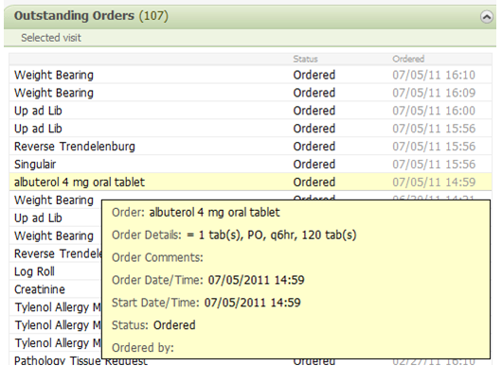

**Purpose**: Provide a custom component that looks and feels similar to the outstanding orders standard component (shown above), but provides a means to not show as much information/rows by separating into individual components. This will be done by providing 2 custom components all using the same custom component code, but flexed by component options (one component namespace but five different component options). Outstanding orders are orders that have not reached a “completed” status. This component must work on a Summary and Workflow views.

**Requirements**:

1. Create a CCL script that takes patient id, encounter id, catalog_cd string (should be the display key). Script will return information shown in screenshot above.
2. The two different options created will include the following and be flexed by parameters passed to the CCL script:
   1. Laboratory
   2. Dietary
3. Create front-end javascript/css to match current outstanding orders component.
4. Make sure to test on Summary and Workflow MPages

**Student Responsibilities**:

Student 1 🡺 Start creation of CCL script making sure to match the requirements above. Set-up everything including the record structure BUT do not write query to pull data yet.

Student 2 🡺 Create query to pull data needed for component and test CCL script by itself

Student 3 🡺 Create custom component javascript such that it calls the CCL script created but only shows the JSON string in the component body.

Student 4 🡺 Setup a view in Bedrock which has two custom components: “Laboratory Outstanding Orders” and “Dietary Outstanding Orders”. Also create a tab in Prefmaint to show your newly created view.

Student 5 🡺 Update javascript code to display face-up columns of data on component (ie Order Name, Status, and Ordered Date/time)

Student 6 🡺 Update javascript code to display hover tip using jquery plugin used in custom component exercises.

Student 7 🡺 Fix stylesheet to display component per screenshot above. This student may need to intervene while students 5 and 6 are working.

Student 8 🡺 Test custom component on multiple patients and make sure all logic is sound.